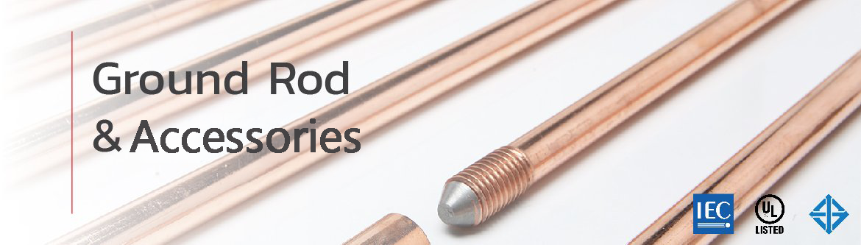
Kumwell Copper-Bonded Ground Rod
Kumwell copper-bonded ground rods feature a copper bonding thickness of over 0.25 mm (250 microns), providing a service life of more than 40 years (General soil condition). We are proud to be the first manufacturer in Thailand certified with the Thai Industrial Standard (TIS 3024 Part 2-2020), and our products also tested IEC 62561-2 and UL 467 international standards.
This ensures superior durability, safety, and long-term reliability for every electrical grounding system.
UL Series
The UL Series ground rods are certified by UL and test according to IEC 62561-2 standards.
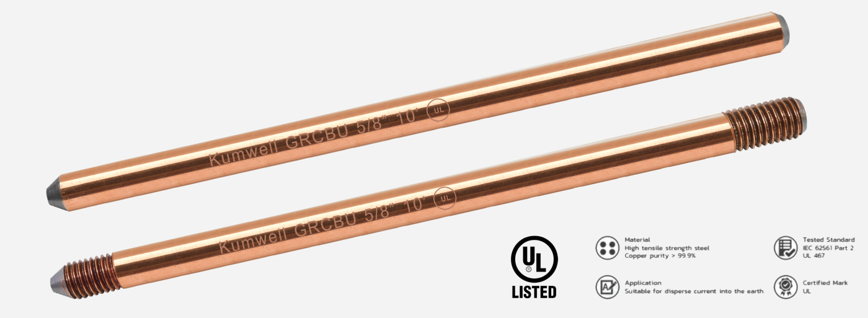

Kumwell Solid Copper Ground Rod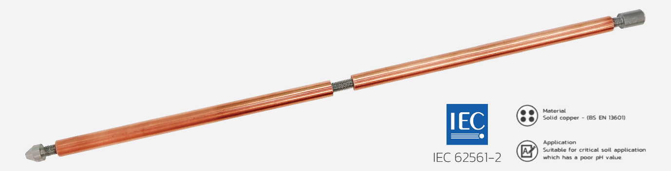
Made from 99% pure copper, high strength and high resistance in demanding environments, including coastal areas and soils with pH values > 8. The product is according to IEC 62561-2 standard.
**Caution: Do not drive the rod directly into the ground. It is recommended to dig a hole prior to installation to prevent damage or breakage of the ground rod.

Kumwell Stainless Steel Ground Rod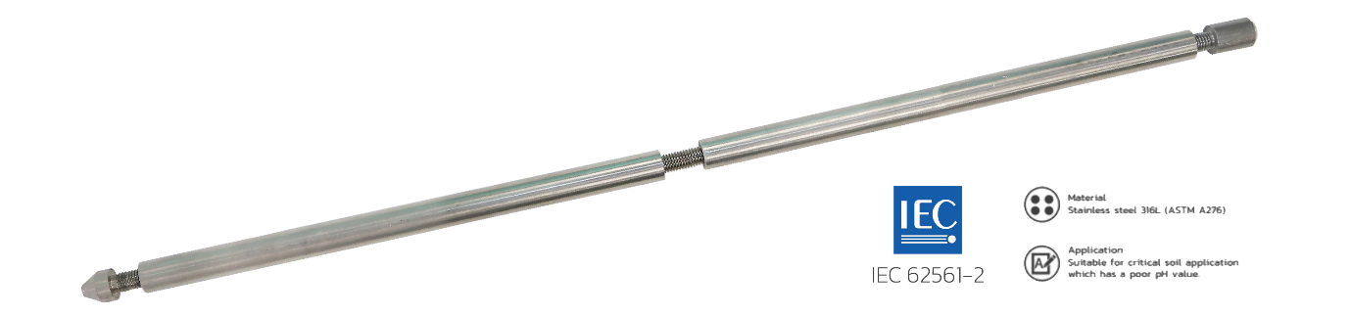
Made from 316L stainless steel which provides superior corrosion resistance in all environments, particularly in soils with pH values < 6. Grade 316L stainless steel features a low-carbon composition and delivers stronger weld joints compared to standard 316 when applied with Exothermic welding. The product is according to IEC 62561-2 standard.
**Recommendation: To comply with IEC 62561-2 standard, stainless steel ground rods must contain more than 2% molybdenum to ensure resistance against rust and corrosion. Therefore, grade 304 stainless steel is not compliant with this standard.

Coupling
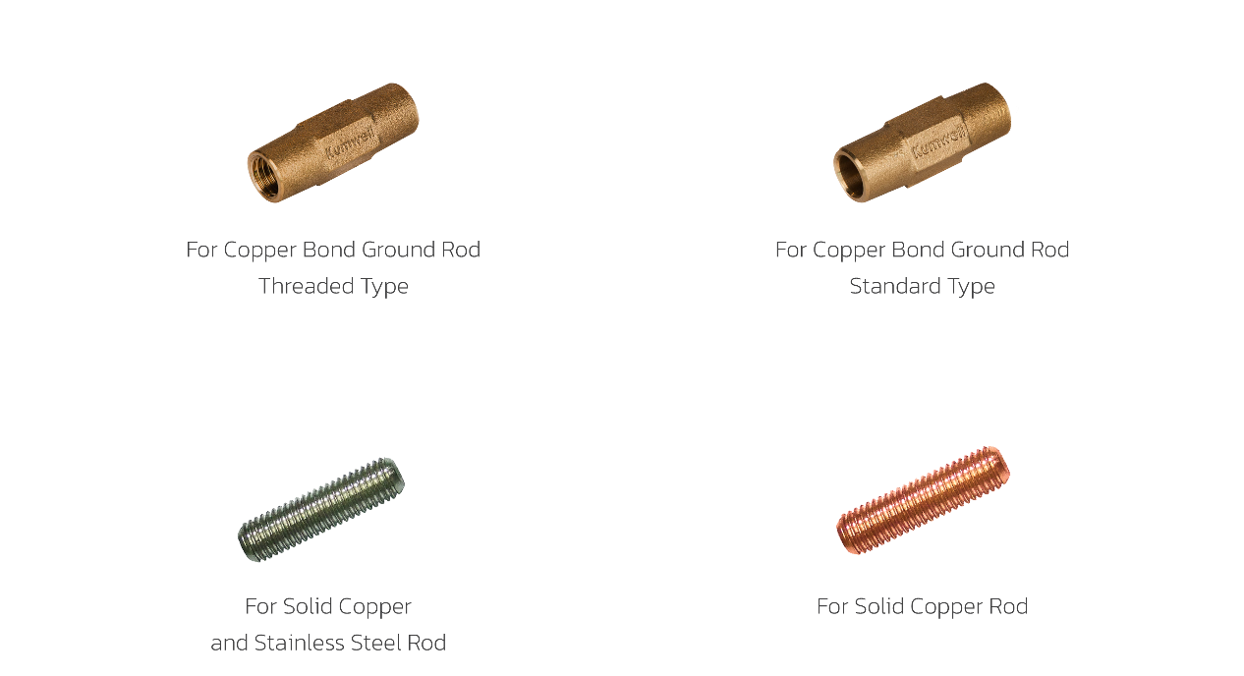
Driving Head
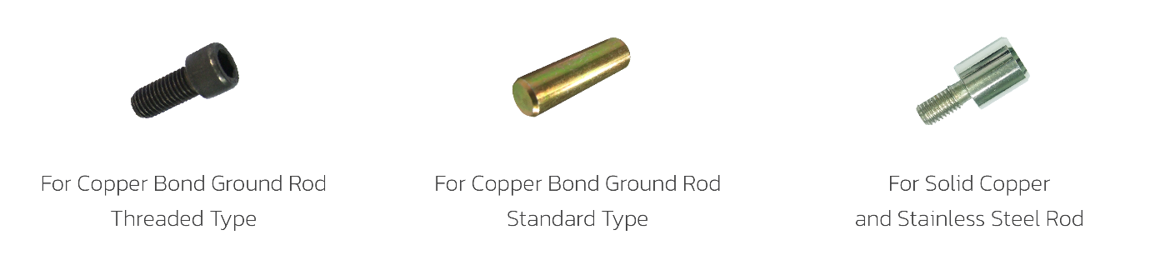
Tip
